Name: Xiaoxiao WU

Assistant Professor of Advanced Materials Thrust

Email: xiaoxiaowu@hkust-gz.edu.cn

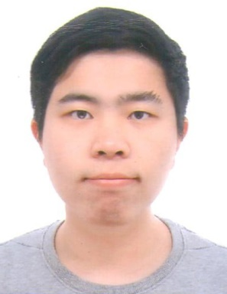

Biography:

Dr. Xiaoxiao Wu is an Assistant Professor of Advanced Materials Thrust at HKUST(GZ). He received Bachelor’s degree in Physics from Nanjing University in 2014, and PhD degree in Physics from Hong Kong University of Science and Technology in 2018. Before joining HKUST(GZ), he was a post-doctoral researcher in Prof. Xiang Zhang’s group in HKU from 2019 to 2022. Until now, he has authored more than 30 journal papers, 11 as the first author or co-first author, 5 as the co-corresponding author, and has published on top journals such as Nature Communications and Physical Review Letters. According to Google Scholar, Dr. Wu has been cited more than 900 times, and more than 600 times as the first author, co-first author, or co-corresponding author, and Dr. Wu’s h-index is 15. He also has 4 granted patents on metamaterials.

Research Interest:

Dr Wu’s research features extraordinary manipulations of waves beyond conventional limits using metamaterials, which control wave-matter interaction on demand through designed ensembles of artificial structures (“meta-atoms”). With a problem-driven approach, his research interest spans on a variety areas of metamaterials, including wave-functional metamaterials, which aim at challenges impossible for plain natural materials, and topological metamaterials, which aim at exploring the profound topological physics in photonic and phononic systems for fundamental progress and also exotic applications. On wave-functional metamaterials, Dr. Wu designed and realized the first bilayer metasurface for near-unity circular polarization conversion (APL, 108, 183502(2016)). On topological metamaterials, Dr. Wu achieved the first direct observation of valley-polarized edge states (Nat. Comm, 8, 1304 (2017). Citations > 200), and proposed the first scheme for topological corner modes of arbitrary shape (PRL, 126, 226802 (2021)).

